
Arkansas School Band and Orchestra Association
Adjudicator’s Comment Sheet – Concert

CLASS - |  |  |  | DAY - |  |  |  | TIME -
NAME OF BAND OR ORCHESTRA -
SCHOOL - |  |  |  |  |  |  |  |  | CITY -
SELECTIONS PLAYED:
 | TITLE |  |  |  |  | COMPOSER |  |  |  | ID # |  | GRADE
1
2
3
The number of students per grade used in this organization:
 |  | 7- | 8 - |  | 9 - |  | 10 - |  | 11 - |  | 12 -
Grade majority of students were beginners -

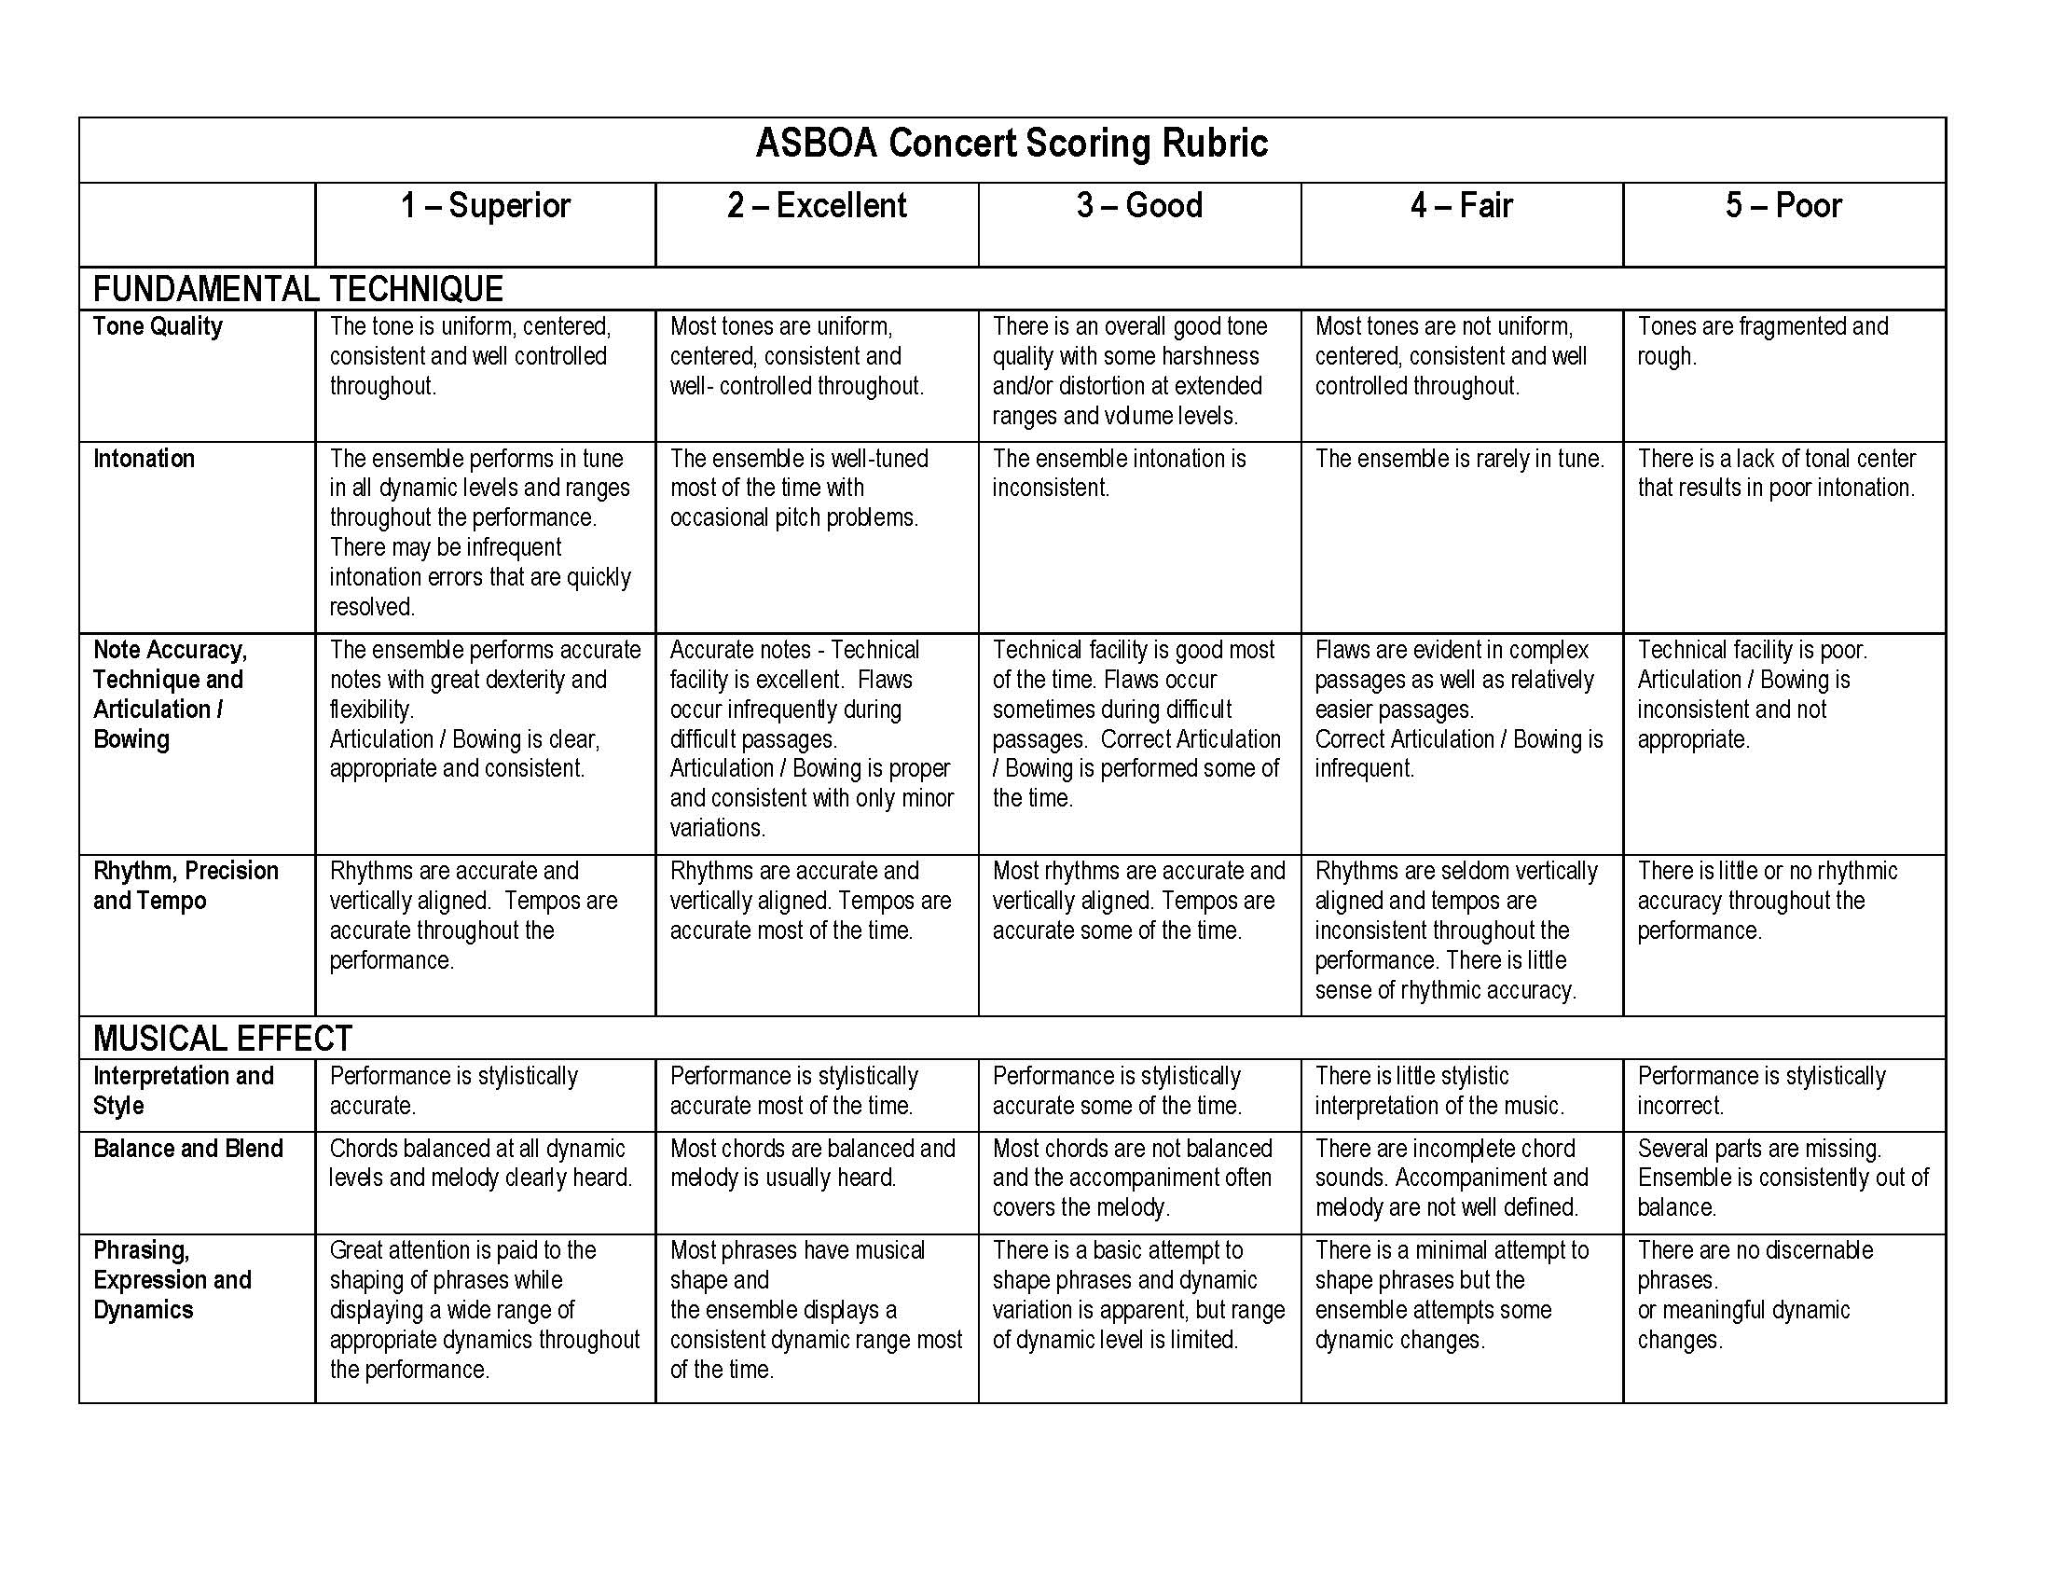
Signature of Adjudicator ___________________________________________________

The items circled or underlined by the adjudicator in the areas of concern on the rubric should accurately reflect the ensemble’s overall rating.

Fundamental Technique Comments

Musical Effect Comments

Additional Comments
(Including Stage Presence, Discipline, Posture, Strong Points, Weak Points)

Recommended for Division _______________________________ _________________________________________________
1 2 3 4 5 Signature of Adjudicator
Circle & Write Out (I, II, III, IV or V)

